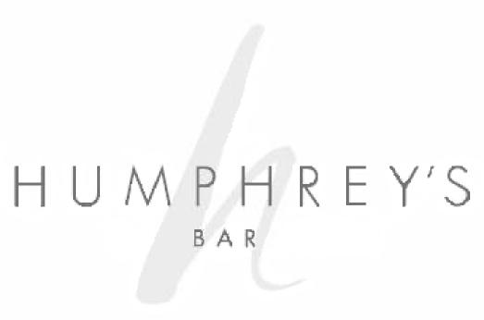
Humphrey’s Bar is named after
Captain Humphrey
of Gloucester Road.

Who found his fortune in the discovery of herbs spices and botanicals which he imported back to Great Britain.

On these long voyages he would blend what he had discovered with the sailor’s Rum or with his preferred choice Gin, to make a passable cocktail to serve at the Captains table.

He had a reputation of being a lover of the finest things that life had to offer whilst globetrotting.

He fell in love with Singapore and continued to trade within the empire, whilst contemplating his success over a Sling.

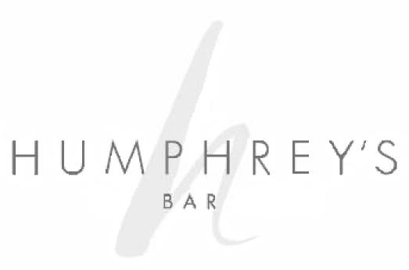

Cocktails

“Never trusty a complicated cocktail that remains perfectly clear until the last ingredient goes in, and immediately clouds”
Terry Pratchet author

Classic Cocktails
Long Island Iced Tea 14
Tequila, white rum, gin, vodka, triple sec,
lemon juice, Coca Cola all served over ice
Classic Negroni 10
Beefeater gin, Vermouth, Campari,
orange, all stirred together over ice
Mojito 9
Havana Club 3yro, fresh mint, brown sugar,
lime & dash of soda water

Martinis
“One martini is all right.
Two are too many and three is not enough”
James Thurber

French Martini 11
Belvedere vodka, Chambord,
pineapple juice
Espresso Martini 11
Vanilla vodka, Kahlua, espresso,
dash of sugar syrup
Lychee Martini 11
Lychee liqueur with a touch of lime,
topped with Beefeater gin and shaken

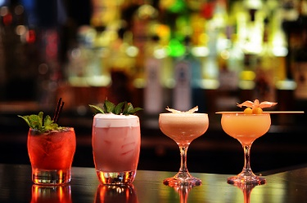
A Taste of Hong Kong
Signature cocktails
Hong Kong Sling 14
Bombay Gin, lychee liqueur,
lemon juice, honey, soda water,
combiner liqueur

Orchard Bellini 10
Lychee liqueur and topped with prosecco

Green Bastard 14
Hendricks Gin, Elderflower liqueur, apple juice,
lemon juice, cucumber and basil

Cocktails of the Month
Designed by our Bar team, please ask your server for this month’s choice

Non Alcoholic Cocktails
Fizz Ripple 7
Fresh raspberries & sugar syrup muddled
with mango and topped up with soda water
over crushed ice
Virgin Mojito 7
Fresh mint & lime muddled together
with brown sugar, topped up with soda water
over ice, cool and refreshing

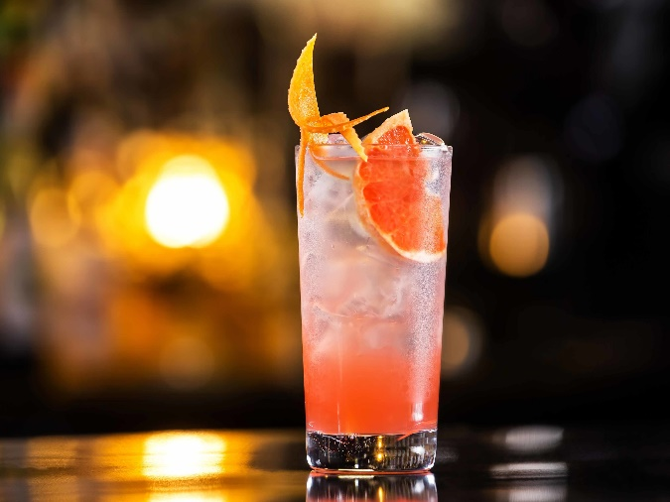

Wine, Beer Booze & Bubbles

All spirits are served in 25ml, fortified wines in 50ml.
Wines are served in 175ml and 250ml.
A measure of 125ml is available on request.
All prices include VAT and a discretionary service charge of 10% will be added to your bill

Champagne & Bubbles
“A magnum of champagne is a perfect size for two gentlemen, as long as one is not drinking.”
Winston Churchill
Glass Bottle
Moët & Chandon Brut NV 68
France
A well-known blend of older reserves
and young wines

Veuve Clicquot Yellow Label Brut 75
France
Full, yet dry with a rich and creamy style
and biscuit flavours

Prosecco DOC Bel Star NV 8 38
Italy
Light and fresh with lively
pear drop flavours

White

175ml 250ml Bottle

Tasari Inzolia Terre 6 9 25
Sicily, Italy
Light, Bold and crisp,
with delicate flavours of citrus

Vinho Verde Branco 6.5 6.5 27
Conde Villar
Portugal Soft minerality and tropical
with beautiful floral hints

Chardonnay 7 10 29
Argento
Argentina Full bodied with citrus
and ripe fruit flavours

Pinot Grigio 7 9.5 29
Argento
Argentina
Light and refreshing with apple,
pear and lemon aromas

Sauvignon Blanc 8.5 12 35
Johnson Estate
South Africa Passion fruit and grapefruit
with a long refreshing finish

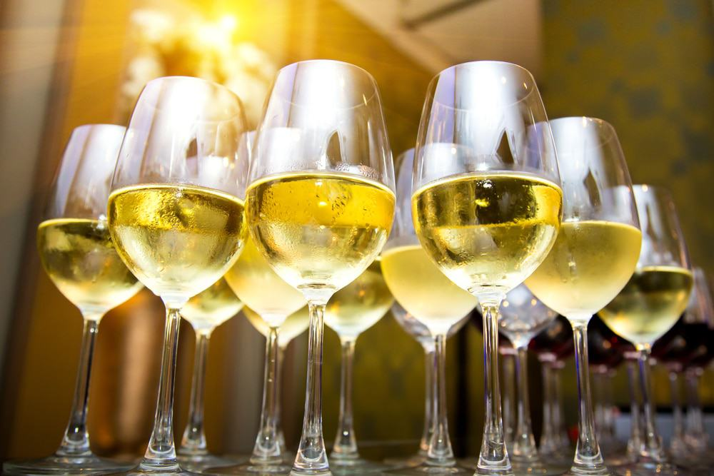

Red

175ml 250ml Bottle

Grenache 6 9 25
La Picoutine
France Soft full-bodied and fruity

Sangiovese 6.5 9 26.5
Fico Grande
Italy Lovely sour cherry and
red fruit characters
with spice coffee and chocolate

Merlot 6.5 9.6 27.5
Valdiviseo
Chile Cherry and red fruit
characters with spice

Malbec 7.5 10.5 30
Argento
Argentina Concentrated cherry and
red fruit characters
with blackcurrant

Rioja Tinto 9 13 38
Bhilar Plots
Spain Full bodied with intense
fruit characters with spice

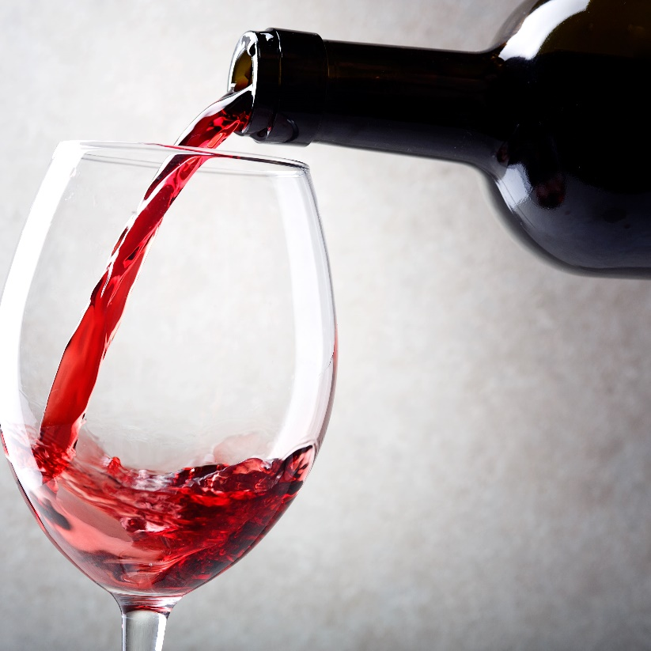

Rosé

175ml 250ml Bottle
Pinot Grigio Blush 6.5 9 25
La Maglia Rosa
Italy Subtle red
fruit flavours – Semi sweet

Rose 8 11 32
Chateau d’Astros Cotes de Provence
France Pale pink with
flavours of wild strawberries – Dry

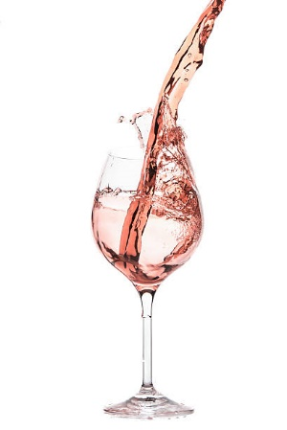

BOOZE
Gin
Boroughs Beefeater 5
Beefeater Pink 6
Monkey 47 7.5
Bombay Sapphire 5.5
Tanqueray 6
Hendricks 6.5
Vodka
Absolut Blue 5
Absolut Citron, Raspberry or Vanilla 5.5
Belvedere 6.5
Grey Goose 7.5
Rum
Havana Club 3 Year Old 5
Captain Morgan Dark Rum 5
Bacardi 6
Rebellion Spiced Rum 6
Havana Club 7 Year Old 6.5

Aperitifs & Liqueurs
Pimm’s No.1 5
Martini Vermouths 4.5
Aperol 5
Campari Bitters 5.5
Archers Peach Schnapps 4.5
Malibu 6
Baileys Irish Cream 5
Tia Maria 6
Kahlua 6
Jagermeister 6
Amaretto Disaronno 6.5
Southern Comfort 7
Grand Marnier 7
Drambuie 7

All spirits and liqueurs are served in 25ml measures, fortified wines in 50ml.

Whiskies

Jameson Irish 5
Johnnie Walker Black Label 7
Johnnie Walker Red Label 6
Chivas 12-Year-Old 6.5
Glenlivet 12-Year-Old 7.5
Bruichladdich Classic 7
Laphroaig Islay Malt 7.5
Glenmorangie Original 6.5
Lagavulin 16-Year-Old 8
Talisker Highland Malt 8.5
Bourbon
Jack Daniels 5
Woodford Reserve 7.5

Tequila
Olmeca Blanco 5
Patron Silver 8
Jose Cuervo Gold 5
Brandies &
Cognac
Martell VS 5.5
Courvoisier VSOP 7.5
Hennessy XO 16

All spirits and liqueurs are served in 25ml measures, fortified wines in 50ml.

Beers, Lager, Ciders &
Soft Drinks
Draught ½ pint Pint

Amstell 3.5 6
Heineken Premier 3.5 6
Coast to Coast 4 7
Guinness 7

UK Beers

Meantime London Lager 5.5
Meantime Pale Ale 5.5

International Beers

Becks Blue (Alcohol Free) 4
Peroni 5.5
Tiger 5.5
Heineken 5
Cider
Bulmers Original 6
Bulmers No.17 Berry 6

Soft Drinks
Coca-Cola / Diet Coke / Coke Zero 3.5
Sprite 3.5
Red Bull 4.5
Fever Tree Tonic Waters 3
Mixers 3
Juices 3.5
J20 4

Bottled Water
330ml Still & Sparkling 3.5
750ml Still & Sparkling 4.5

Food Menu
12am – 10pm

All prices include VAT and a discretionary service charge of 10% will be added to your bill

All Day Dining Menu

Starters & Salads

Smoked Salmon 13
Salad, toasted French baguette bread, lemon oil

Caesar Salad (V) 8
Romaine lettuce hearts, herbs baked crouton,
shaved parmesan
ADD
Chicken 4
Tiger Prawn 5

Greek Salad (V) 8.5
Tomatoes, cucumber, onion, green bell peppers, feta cheese, olives, oregano, olive oil

Hummus 7.5
Mashed chickpeas blended whit tahini, lemon juice andgarlic

Mozzarella Caprese 10
Sliced tomato salad with mozzarella cheese,
basil and olive oil

Vine Tomatoes & Shallot Salad 6.25
With herbs, french dressing
Chef’s Soup for the Day 7.5
With bread rolls

Lighter Bites

Duck Spring Rolls 7.5
Shredded duck roll served with hoisin sauce

Vegetarian Spring Rolls 7.5
Served with sweet chili dips

Please be advised that allergens may be present in our kitchens. If you are an allergen sufferer, please ask your server for more detailed information. Our recipes are subject to change,
therefore, you are advised to check allergen information on every visit.

Sandwiches
Your choice of white or malted bloomer, served with French fries and salad
Gloucester Club 14
Toasted triple decker with bacon, chicken, egg,
lettuce, tomato, mayonnaise

Tuna, Ham and Sweetcorn Mayonnaise 10
Thick white bread, loads of cheddar cheese and
sliced ham

Mixed Leaves, Tomatoes, Cheddar (V) 7.5
Onion chutney

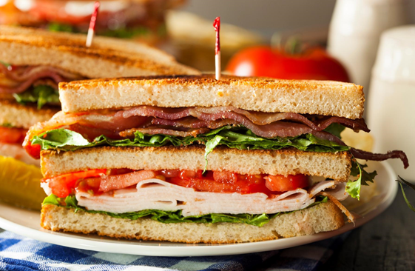

Mains
Wells Farm 8oz Sirloin Steak 25
French fries, salad, béarnaise sauce
Pane Fried Salmon Fillet 15
Roast new potato, mixed vegetables, salad
Hollandaise sauce
Fish ‘n Chips 14.5
Battered cod with peas, chips, tartar sauce

Indian Specials
Chicken Jalfrezi 13.5
Basmati rice & raita dip, naan bread
Chicken Tikka 13.5
Basmati rice & raita dip, naan bread
Lamb Rogan 14
Basmati rice & raita dip, naan bread
Beef Madai 14.5
Basmati rice & raita dip, naan bread
Goan Fish Curry 12.5
Basmati rice & raita dip, naan bread
Chickpea, Sweet Potato & Spinach Curry (V) 12
Basmati rice & raita dip, naan bread

Please be advised that allergens may be present in our kitchens. If you are an allergen sufferer, please ask your server for more detailed information. Our recipes are subject to change,
therefore, you are advised to check allergen information on every visit
Pasta & Burger

Spaghetti Bolognaise 13.5
Parmesan cheese
Penne al’arabiata 12.5
Penne pasta with tomato, garlic sauce
Gloucester Burger 7oz 14
Grilled beef burger with tomato, cheddar cheese,
lettuce, french fries,
Roasted Chicken Burger 13
Grilled chicken breast, tomato, lettuce,
Cheddar cheese, french fries

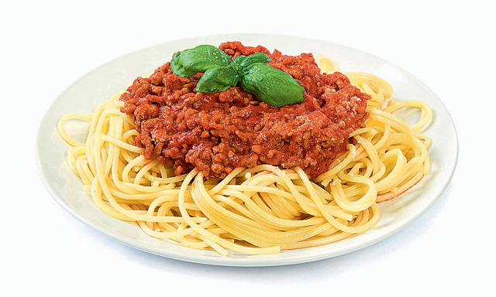

Pizza
Margarita (V) 14
Thin and crispy pizza topped with
grated mozzarella and tomato
Quarto Fromaggi (V) 14.75
Goat cheese, stilton cheese, parmesan cheese,
grated mozzarella cheese
Peperoni 14
Tomato, grated mozzarella cheese

Add additional toppings 2.5

Sides 4
Marinated Mix Olives
French Fries
Battered Onion Rings
Seasonal Vegetables
Mixed Leaves Salad
Vine Tomato, Red Onion Salad

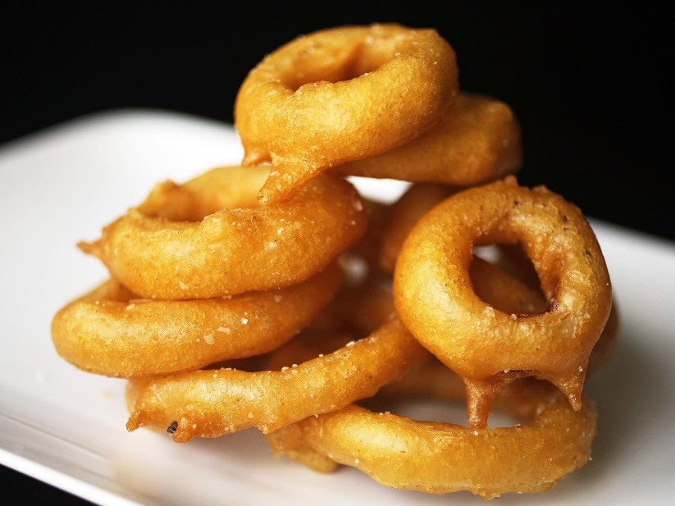

Please be advised that allergens may be present in our kitchens. If you are an allergen sufferer, please ask your server for more detailed information. Our recipes are subject to change,
therefore, you are advised to check allergen information on every visit.

Desserts
Crème Brule 6
Vanilla Cheesecake 7.8
With soft berry compote
Carrot Cake 7.5
Fresh Fruit Salad 5
Selection of Ice Creams 5
With soft berry compote

Please be advised that allergens may be present in our kitchens. If you are an allergen sufferer, please ask your server for more detailed information. Our recipes are subject to change,
therefore, you are advised to check allergen information on every visit.

Kids Menu

Starters

Cheesy Garlic Bread 4
Melon with forest fruit berries (V) 6
Seasonal soup with bread (V) 7

Mains

Cod Goujon 11.5
Chips, tartar sauce
Sausages & Mash 10.5
Roast Cumberland sausage,
potato mash, onion gravy
Penne Pasta 9.5
Tomato sauce and cheese
Pizza Peperoni 14
Tomato, grated mozzarella cheese

Desserts
Crème Brule 6
Vanilla Cheesecake 7.8
With soft berry compote
Carrot Cake 7.5
Fresh Fruit Salad 5
Selection of Ice Creams 5
With soft berry compote

Please be advised that allergens may be present in our kitchens. If you are an allergen sufferer, please ask your server for more detailed information. Our recipes are subject to change,
therefore, you are advised to check allergen information on every visit.
Coffee Selection
Espresso 3
Classic Italian coffee,
rich in taste with a crema top

Double Espresso 3.5

Macchiato 3.5
Double espresso shot
topped with a touch of foam

Americano regular 3.5 large 4.5
Rich full bodies’ espresso shot
topped with hot water

Cappuccino regular 4 large 5
Espresso with steamed foamy milk
and a chocolate dusting

Latte regular 4 large 5
Rich espresso in steamed milk,
with a touch of foam.
Choice of full milk, skinny or soya

Mocha regular 4 large 5
Classic hot chocolate added shot of espresso,
your choice of cream on top

Flat White 4
Espresso with steamed cream milk

Baby chino 2.5
Touch of chocolate powder and
hot milk with hot foam

Hot Chocolate 4

Iced Coffee
Your choice of above coffees over ice

Please be advised that allergens may be present in our kitchens. If you are an allergen sufferer, please ask your server for more detailed information. Our recipes are subject to change,
therefore, you are advised to check allergen information on every visit.

